
Център за обучение по софтуерно тестване Website: http://skillo-bg.com
Bug Template
Bug ID | PSB001
Name | Wrong website loads when clicked on field “3 days Sale Get up to 25% off”
Priority | P1
Severity | S2
Description
Steps to reproduce | - Load URL http://automationpractice.com/index.php  - Click on field “3 days Sale Get up to 25% off”  Expected Result – load promo page with products being on Sale  Actual Result – load completely different site https://www.prestashop.com/en
Attachment | 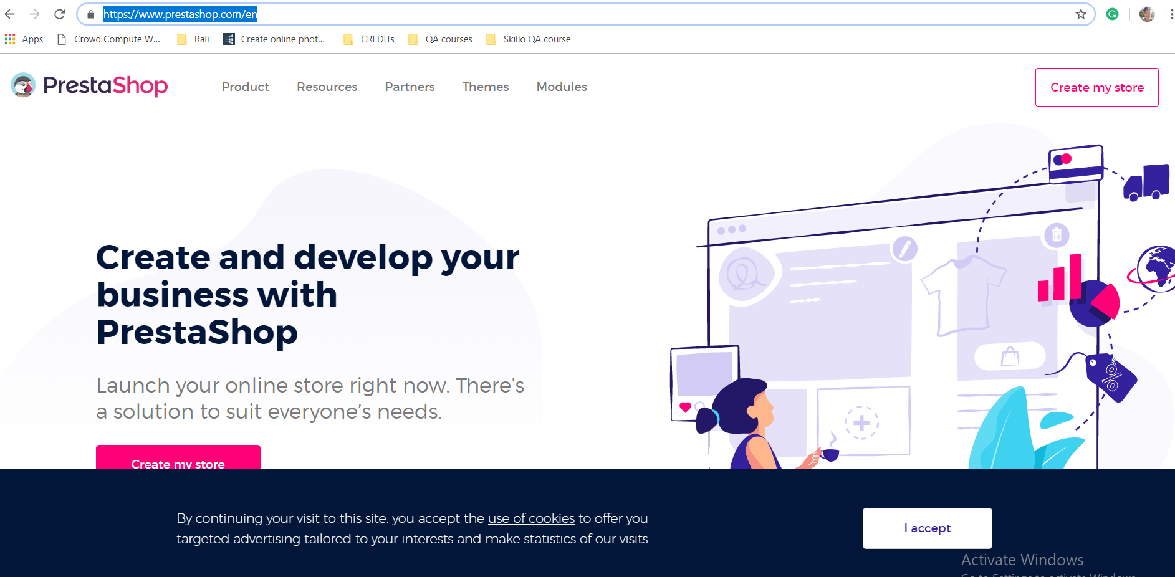
Status | New
Component | Homepage
Version/Build number (Found in) | Build version 2019
Environment | Google Chrome Version 73.0.3683.103 (Official Build) (64-bit)
Comments
Date Created | 16/04/2019
Author | Ralitsa Parshorova
Audit Log | History of the changes for this bug

